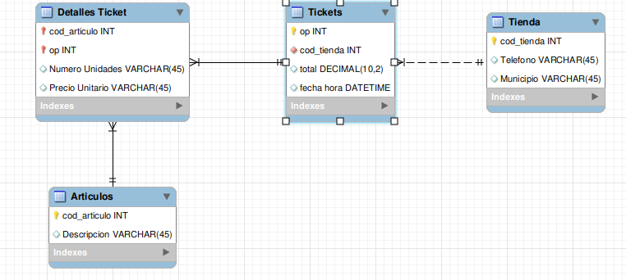

**CREATE TABLE tienda (**

cod_tienda int primary key,

telefono varchar(20),

municipio varchar(45),

descripcion varchar(45)

) ;

**CREATE TABLE articulos (**

cod_articulos int primary key,

descripcion varchar(45)

) ;

**CREATE TABLE tickets (**

op int primary key,

total decimal (10,2),

fecha_hora datetime,

cod_tienda int,

foreign key (cod_tienda)

references tienda (cod_tienda)

) ;

**CREATE TABLE detalles_tickets (**

cod_articulos int,

op int,

numero_unidades varchar(45),

precio_unitario varchar(45),

primary key (cod_articulos, op)

foreign key (cod_articulos) references articulos (cod_articulos),

foreign key (op) references tickets (op)

) ;

**insert into tienda (cod_tienda, descripcion, municipio, telefono)**

Values (2463, "AVDA EUCALIPTOS","PETRER","965377981"),

(2194, "C/LAGO DEL RETIRO","PARLA","916993558"),

(2145, "AV CADIZ", "CORDOBA", "957481935") ;

**INSERT INTO tickets (op, cod_tienda, fecha_hora, total)**

values (78910, 2145, "2013-10-01 09:35", 12.54),

(188185, 2194, "2022-03-19 14:34", 16.85),

(132555, 2194, "2022-03-29 14:08", 26.93),

(147545, 2463, "0217-10-31 19:55", 32.68) ;

**insert into articulos (cod_articulos, descripcion, precio_unitario)**

values

(1, "NAPOLITANA CREMA", 1.80),

(2, "ARROZ CHOCOLATEADO", 1.55),

(3, "PATATAS BRAVAS", 1),

(4, "PATATAS CORTE GRUESO", 1.05),

(5, "BOLSA PLASTICO", 0.15),

(6, "GEL DERMO AVENA", 1.20),

(7, "MAGDALENA BOLSON", 2.60),

(8, "CR MANOS CONCENTRADA", 1),

(9, "YOGUR SABORES 16", 2.30),

(10, "FLAN HUEVO X9", 2.45) ;

**INSERT INTO detalles_tickets**

(op, cod_articulos, numero_unidades, precio_unitario)

VALUES

(188185, 1, 2, 1.15), (188185, 2, 1, 1.55), (188185, 3, 1, 1),

(188185, 4, 1, 1.05), (188185, 5, 2, 0.15), (188185, 6, 1, 1.2),

(188185, 7, 1, 1.7), (188185, 8, 1, 1), (188185, 9, 1, 1.85),

(188185, 10, 2, 2.45) ;

**insert into articulos (cod_articulos, descripcion, precio_unitario)**

values

(11, "SOBAOS", 1.80),

(12, "COPOS DE MAIZ 0%", 1.05),

(13, "GALLETA TOSTA-RICA", 2),

(14, "AZUCAR BLANCO", 1.6),

(15, "BANANA", 0.99) ;

**INSERT INTO detalles_tickets**

(op, cod_articulos, numero_unidades, precio_unitario)

VALUES

(132555, 11, 1, 1.8), (132555, 1, 2, 1.8), (132555, 5, 2, 0.15),

(132555, 7, 2, 2.6), (132555, 12, 1, 1.05), (132555, 13, 1, 2),

(132555, 6, 1, 1.4), (132555, 9, 1, 2.3), (132555, 14, 1, 2.3),

(132555, 15, 1, 2.78) ;